**Project Design Phase-I**

**Solution Architecture**

|  |  |
| --- | --- |
| Date | 19 September 2022 |
| Team ID | PNT2022TMID52672 |
| Project Name | Project – A Novel Method For Handwritten Digit Recognition System |
| Maximum Marks | 4 Marks |

**Solution Architecture:**

Solution architecture is a complex process – with many sub-processes – that bridges the gap between business problems and technology solutions. Its goals are to:

* Find the best tech solution to solve existing business problems.
* Describe the structure, characteristics, behaviour, and other aspects of the software to project stakeholders.
* Define features, development phases, and solution requirements.
* Provide specifications according to which the solution is defined, managed, and delivered.

**Project Description:**

Given that everyone in the world has their own writing style, handwriting detection is one of the most intriguing research projects now underway. It is the computer's capacity to automatically recognise and understand handwritten figures or letters. Because of advances in science and technology, everything is being digitalized in order to reduce human effort. As a result, handwritten digit identification is required in many real-time applications. The MNIST data collection, which contains 70000 handwritten digits, is commonly employed in this recognition process. To train these photos and create a deep learning model, we use artificial neural networks. A web application is developed that allows the user to upload an image of a handwritten digit.

**Example- Solution Architecture:**

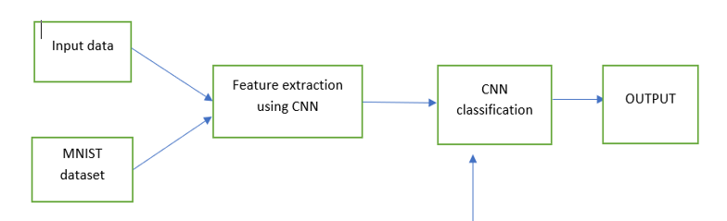



**Solution:**

**MNIST Dataset:**

One of the interesting research projects is the recognition of handwriting. It is the ability of a computer to automatically recognise and comprehend handwritten numbers or letters. Every aspect of life is being digitalized to lessen the need for human labour as a result of advancements in science and technology. Thus, handwritten digit recognition is required in many real-time applications. The MNIST data collection, which contains 70000 handwritten digits, is frequently utilised for this recognition method. In order to train these photos and create a deep learning model, we use artificial neural networks. A web application is developed that allows users to upload pictures of handwritten numbers. This image is examined by the model, which then sends the results back to the user interface. There are 60,000 training and 10,000 testing labelled handwritten digit images in the MNIST Handwritten Digit Recognition Dataset. There are 28 pixels in height and 28 pixels in width in each image, for a total of 784 (2828) pixels. A single pixel value corresponds to each pixel. It tells whether a pixel is bright or dark (larger numbers indicates darker pixel). An integer from 0 to 255 makes up this pixel value.

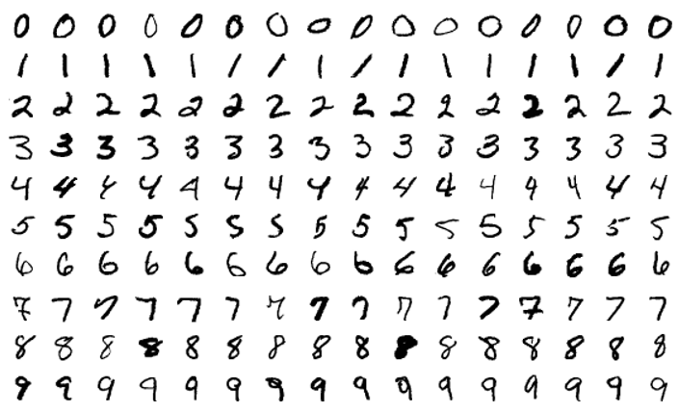

**Procedure:**

1. Install the latest TensorFlow library.
2. Prepare the dataset for the model.
3. Develop Single Layer Perceptron model for classifying the handwritten digits.
4. Plot the change in accuracy per epochs.
5. Evaluate the model on the testing data.
6. Analyse the model summary.
7. Add hidden layer to the model to make it Multi-Layer Perceptron.
8. Add Dropout to prevent overfitting and check its effect on accuracy.
9. Increasing the number of Hidden Layer neuron and check its effect on accuracy.
10. Use different optimizers and check its effect on accuracy.
11. Increase the hidden layers and check its effect on accuracy.
12. Manipulate the batch size and epochs and check its effect on accuracy.

**Approach**:

We will approach this project by using a three-layered Neural Network.

* **The input layer**: It distributes the features of our examples to the next layer for calculation of activations of the next layer.
* **The hidden layer**: They are made of hidden units called activations providing nonlinear ties for the network. A number of hidden layers can vary according to our requirements.
* **The output layer**: The nodes here are called output units. It provides us with the final prediction of the Neural Network on the basis of which final predictions can be made.

A neural network is a model based on how the brain functions. It is made up of several layers with numerous activations, which mirror neurons in our brain. A neural network attempts to learn a set of parameters from a set of data, which may aid in recognising underlying links. Because neural networks can adapt to changing input, they can produce the best possible results without having to rethink the output criteria.

**Neural Network with one hidden layer:**

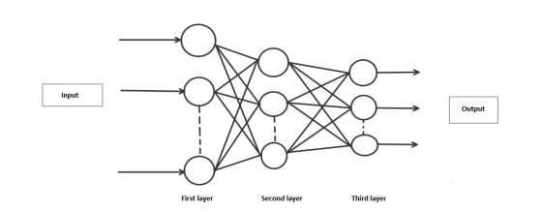

**Algorithm:**

**Forward Propagation Process:**

It's a simple process through which the CNN module will extract the features and categorise the image using them. The architecture displays the network's input layer, hidden layers, and output layer. The feature extraction phase of the network involves multiple layers and uses convolution and subsampling.

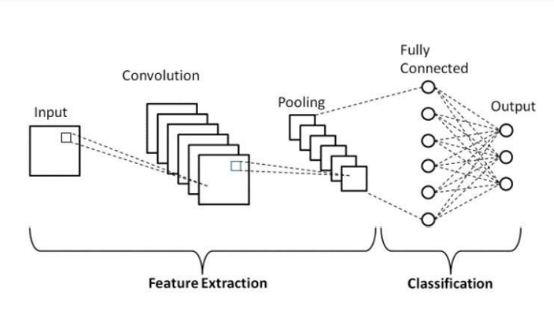

**Working:**

Neural networks take in data and process it through a number of secret layers. Each hidden layer is composed of a group of neurons, each of which is completely linked to every neuron in the layer above. A single layer of neurons has totally independent functioning. "Output layer" refers to the final layer that is entirely connected.

**Convolution Layer:**

The fundamental component of a CNN is the convolutional layer. The parameters of the layer are a set of learnable filters that cover the entire depth of the input volume but have a narrow receptive field. Each filter is convolved across the width and height of the input volume during the forward pass, computing the dot product between each filter entry and the input to create a two-dimensional activation map of the filter. As a result, the network picks up filters that turn on when they spot a certain kind of feature at a particular location in the input.

**Feature Extraction:**

The weights of each neuron in a feature are the same. In this manner, the same feature is recognised by all neurons at various locations in the input image. Limit the number of unrestricted parameters. Subsampling Layer:

Reducing the overall size of a signal is referred to as subsampling, sometimes known as down sampling. Each feature map's spatial resolution is decreased by the subsampling layers. Shift or distortion invariance is attained, and the impact of sounds is lessened.

**Pooling layer:**

In a Convent architecture, it is typical to sporadically introduce a Pooling layer between succeeding Conv layers. In order to decrease the number of parameters and computation in the network and, as a result, control overfitting, it gradually shrinks the spatial size of the representation. Every depth slice of the input is independently processed by the Pooling Layer, which then applies the MAX operation to resize each slice spatially.

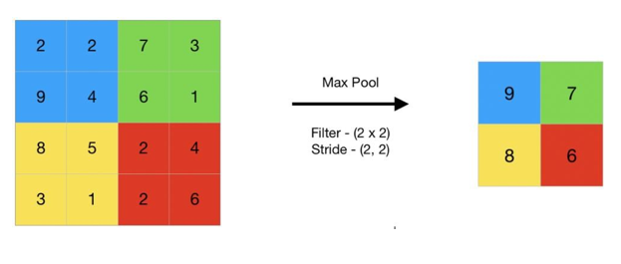

**TensorFlow:**

An open-source machine learning library for both research and production is called TensorFlow. TensorFlow provides developers of all skill levels with APIs for desktop, mobile, web, and cloud applications. To get started, refer to the sections below. We can achieve text output and sound output by scanning the number digit and converting it to png format using the python3 command in terminal.

**Result:**

As with any study or project undertaken in the field of machine learning and image recognition, we are not claiming that our results are infallible, as with any endeavor in the fields of machine learning and image processing. There is always opportunity for methodological development in the field of machine learning; there will always be a fresh new idea that solves the same problem more effectively. Three models were used to test the application: Convolution Neural Network, Multi-Layer Perceptron (MLP), and (CNN). The classifier accuracy varies with each model, allowing us to determine which is more accurate.